SIMATS ENGINEERING
ASSESSMENT TOOLS
Course Name: Theory of Computation
Course Code: CSA1304
Course Outcome (CO4): Construct Context-Free Grammars, generate derivations and parse trees to demonstrate the syntactic structure of strings. (BL: 3)
Assessment Tool: Industry Problem
Weightage: 20%
Total Marks: 100
Duration: 1 Hour

Name / Reg. No.: SRIVARSHA M-192371010
I certify that this submission is my original work and that I have adhered to the guidelines specified for this assessment. I understand that any violation of academic integrity rules will result in disciplinary action.
Signature of the student: SRIVARSHA M

Question 1 — DFA-based Validation Module (C)
Problem: Design and implement a C-based validation module that simulates a Deterministic Finite Automaton (DFA) accepting only strings that begin with 'a' and end with 'a'. The module must read input dynamically, apply DFA state transitions, and print Accepted or Rejected.

1.1 DFA Design
Alphabet: Σ = {a, b}. The DFA needs to remember two things as it scans left to right: (1) whether the string started with 'a' at all, and (2) whether the character read most recently was 'a'. This gives four states:
- q0 — start state, no input read yet.
- q1 — string started with 'a' and the last character read so far is 'a' (accepting state).
- q2 — string started with 'a' but the last character read so far is 'b'.
- q3 — dead/trap state: the very first character was 'b', so the string can never satisfy the condition.
Formally, M = (Q, Σ, δ, q0, F) where Q = {q0, q1, q2, q3}, Σ = {a, b}, F = {q1}, and δ is:
State | on 'a' | on 'b'
q0 (start) | q1 | q3
q1 (accept) | q1 | q2
q2 | q1 | q2
q3 (dead) | q3 | q3
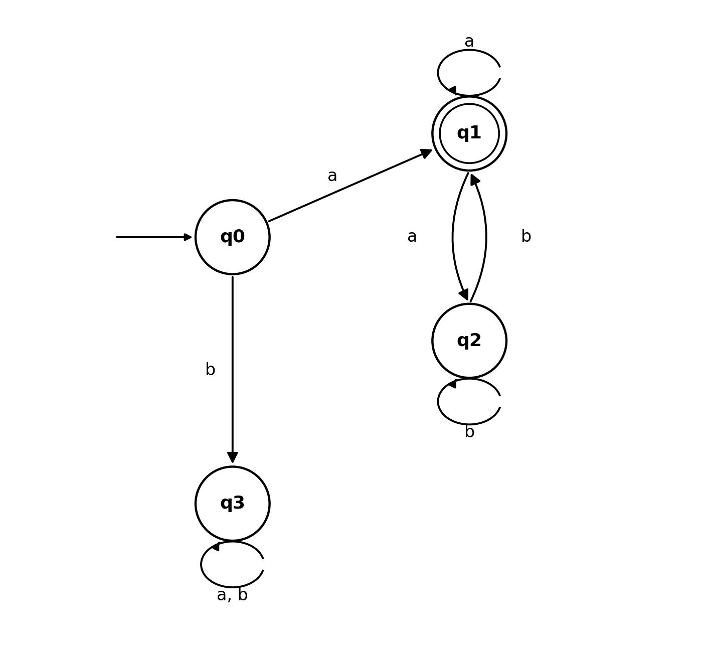
Figure 1: DFA state diagram — accepts strings over {a,b} beginning and ending with 'a'.

1.2 C Implementation
The program below encodes the transition table in a delta() function and drives it character-by-character over the user's input string.
/* Q1: DFA-based validation module
Accepts strings over {a,b} that BEGIN with 'a' AND END with 'a'.
States:
q0 - start state (nothing read yet)
q1 - accepting state: string so far starts with 'a' and current last char is 'a'
q2 - non-accepting: string so far starts with 'a' but current last char is 'b'
q3 - dead/trap state: string does not start with 'a' (all further input rejected)
*/
#include <stdio.h>
#include <string.h>

#define Q0 0
#define Q1 1 /* accepting */
#define Q2 2
#define Q3 3 /* dead state */

int delta(int state, char ch) {
switch (state) {
case Q0:
if (ch == 'a') return Q1;
else return Q3;
case Q1:
if (ch == 'a') return Q1;
else return Q2;
case Q2:
if (ch == 'a') return Q1;
else return Q2;
case Q3:
return Q3;
}
return Q3;
}

int isAccepted(const char *str) {
int state = Q0;
int len = strlen(str);

if (len == 0) return 0; /* empty string cannot start and end with 'a' */

for (int i = 0; i < len; i++) {
char ch = str[i];
if (ch != 'a' && ch != 'b') {
printf("Invalid character '%c' - only 'a' and 'b' allowed.\n", ch);
return 0;
}
state = delta(state, ch);
}
return (state == Q1);
}

int main(void) {
char input[256];

printf("=== DFA Validation Module ===\n");
printf("Accepts strings over {a,b} that begin with 'a' and end with 'a'.\n");
printf("Enter a string (or 'exit' to quit):\n");

while (1) {
printf("\n> ");
if (scanf("%255s", input) != 1) break;
if (strcmp(input, "exit") == 0) break;

if (isAccepted(input))
printf("Result: Accepted\n");
else
printf("Result: Rejected\n");
}
printf("Program terminated.\n");
return 0;
}

1.3 Sample Execution
Sample run:
> a → Result: Accepted
> ab → Result: Rejected
> aba → Result: Accepted
> abba → Result: Accepted
> b → Result: Rejected
> baa → Result: Rejected
(Verified by compiling with gcc and running the above inputs.)

Question 2 — PDA for n0(w) = n1(w)
Problem: Design a Pushdown Automaton that accepts L = { w ∈ (0+1)* : n0(w) = n1(w) }, i.e. binary strings with an equal number of 0's and 1's.

2.1 Design Idea
The stack is used as a running counter of the imbalance between 0's and 1's seen so far. Whenever the next symbol matches what is already sitting on top of the stack (both are the same digit), we push — the imbalance grows. Whenever the next symbol is the opposite digit to the stack top, we pop — the imbalance shrinks and the two symbols cancel out. The string has equal 0's and 1's exactly when the stack returns to just the bottom marker Z at the end of input.

2.2 Formal PDA
P = ({q0}, {0,1}, {0,1,Z}, δ, q0, Z, {q0}), accepting by empty stack (only Z left) at the end of input. δ is given by:
- δ(q0, 0, Z) = (q0, 0Z) — push 0 on an empty stack
- δ(q0, 1, Z) = (q0, 1Z) — push 1 on an empty stack
- δ(q0, 0, 0) = (q0, 00) — top is already 0, push another 0
- δ(q0, 1, 1) = (q0, 11) — top is already 1, push another 1
- δ(q0, 0, 1) = (q0, ε) — top is 1, reading 0 cancels it (pop)
- δ(q0, 1, 0) = (q0, ε) — top is 0, reading 1 cancels it (pop)
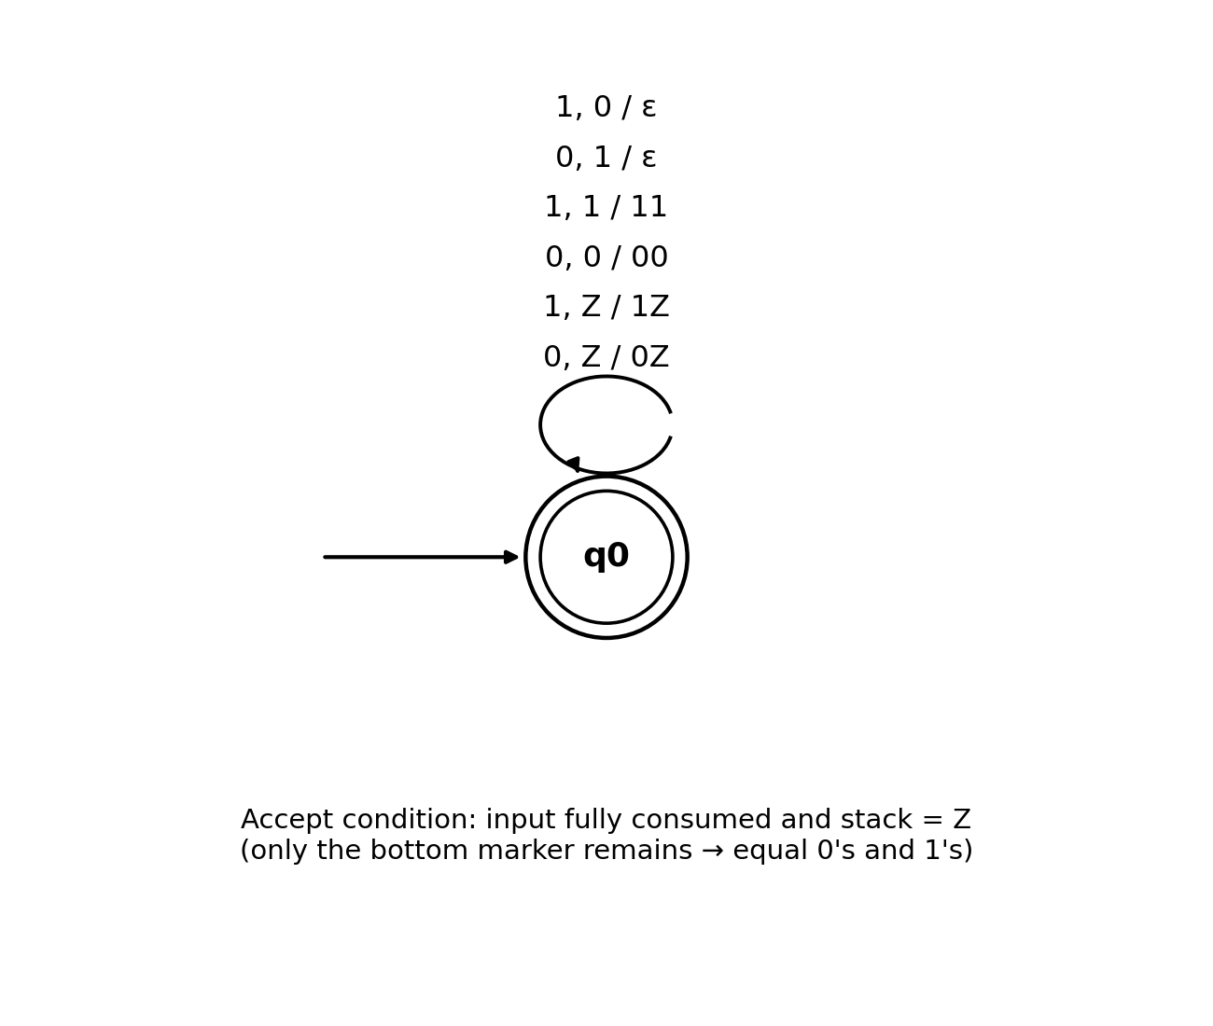
Figure 2: PDA transition diagram for n0(w) = n1(w) (single-state design).

2.3 Trace Example — w = 0101
Step | Input read | Symbol | Stack (top → right)
0 | - | - | Z
1 | 0 | 0 | 0Z
2 | 1 | 1 | Z (0 cancels with 1)
3 | 0 | 0 | 0Z
4 | 1 | 1 | Z (0 cancels with 1)
Final stack = Z (empty) and input fully consumed → 0101 is accepted, matching n0 = n1 = 2.

Question 3 — PDA for L = {aⁿb²ⁿ | n ≥ 1}
Problem: Design a Pushdown Automaton for the language of a's followed by b's, where the number of b's is exactly twice the number of a's.

3.1 Design Idea
Every time an 'a' is read, two copies of a stack symbol X are pushed (so the stack ends up holding 2n copies of X after n a's). Every time a 'b' is read, one X is popped. If, after the input ends, the stack contains only the bottom marker Z, then exactly 2n b's have matched the 2n pushed X's — confirming #b = 2 × #a.

3.2 Formal PDA
P = ({q0, q1, qf}, {a,b}, {X,Z}, δ, q0, Z, {qf}). δ is given by:
- δ(q0, a, Z) = (q0, XXZ) — first 'a': push two X's
- δ(q0, a, X) = (q0, XXX) — each further 'a': push two more X's
- δ(q0, b, X) = (q1, ε) — first 'b' switches to the popping state q1, pops one X
- δ(q1, b, X) = (q1, ε) — each further 'b': pop one X
- δ(q1, ε, Z) = (qf, Z) — accept once only Z remains (stack empty of X's)
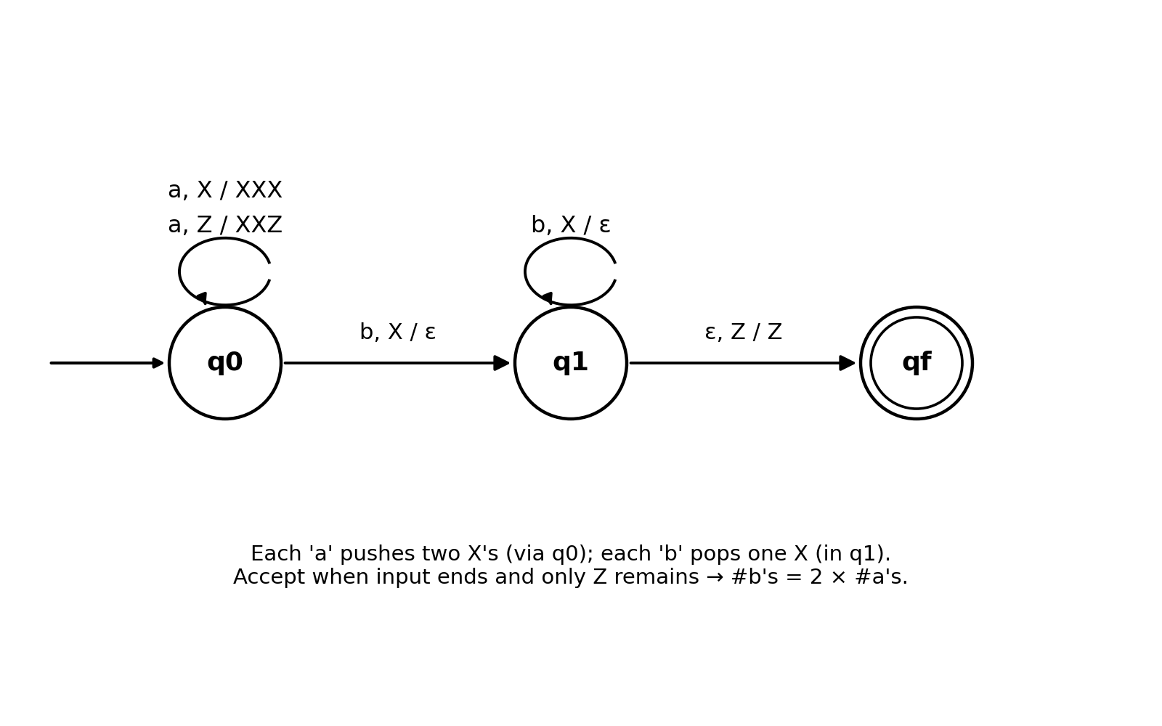
Figure 3: PDA transition diagram for {aⁿb²ⁿ | n ≥ 1}.

3.3 Trace Example — w = aabbbb (n = 2)
Step | Symbol | State | Action | Stack after
0 | - | q0 | - | Z
1 | a | q0 | push XX | XXZ
2 | a | q0 | push XX | XXXXZ
3 | b | q1 | pop X | XXXZ
4 | b | q1 | pop X | XXZ
5 | b | q1 | pop X | XZ
6 | b | q1 | pop X | Z
7 | ε | qf | accept (stack = Z) | Z
2 a's pushed 4 X's, and exactly 4 b's popped them all → aabbbb is accepted, and #b = 2×#a = 4.

Question 4 — ε-closure Computation Module (C)
Problem: Develop a C-based computational module to determine the ε-closure of all states in an NFA with ε-transitions, for use in an automata processing engine (e.g. NFA-to-DFA conversion in compiler construction).

4.1 Design Idea
ε-closure(q) is the set of all states reachable from q using only ε-transitions, including q itself. This is computed with a depth-first search (DFS): starting from q, follow every outgoing ε-edge, mark the destination as part of the closure, and recurse from there, stopping when no new states are discovered. The program stores the NFA's ε-transitions as an adjacency matrix and repeats this DFS for every state so all closures are produced in one run.

4.2 C Implementation
/* Q4: Compute epsilon-closure of every state in an NFA with epsilon-transitions.
The NFA's epsilon-transitions are given as an adjacency matrix read from input.
epsilon-closure(q) = set of all states reachable from q using only epsilon-moves
(including q itself), computed here via depth-first search.
*/
#include <stdio.h>

#define MAX 50

int epsAdj[MAX][MAX]; /* epsAdj[i][j] = 1 if there is an epsilon-transition i -> j */
int visited[MAX];
int n; /* number of states, numbered 0..n-1 */

void dfs(int state, int closure[]) {
visited[state] = 1;
closure[state] = 1;
for (int next = 0; next < n; next++) {
if (epsAdj[state][next] && !visited[next]) {
dfs(next, closure);
}
}
}

void epsilonClosure(int state, int closure[]) {
for (int i = 0; i < n; i++) {
visited[i] = 0;
closure[i] = 0;
}
dfs(state, closure);
}

int main(void) {
int e; /* number of epsilon-transitions */

printf("=== Epsilon-Closure Computation Module ===\n");
printf("Enter number of states: ");
scanf("%d", &n);

for (int i = 0; i < n; i++)
for (int j = 0; j < n; j++)
epsAdj[i][j] = 0;

printf("Enter number of epsilon-transitions: ");
scanf("%d", &e);

printf("Enter each epsilon-transition as: from to (0-indexed states)\n");
for (int k = 0; k < e; k++) {
int from, to;
scanf("%d %d", &from, &to);
epsAdj[from][to] = 1;
}

printf("\n--- Epsilon-Closures ---\n");
for (int state = 0; state < n; state++) {
int closure[MAX];
epsilonClosure(state, closure);

printf("epsilon-closure(q%d) = { ", state);
int first = 1;
for (int i = 0; i < n; i++) {
if (closure[i]) {
if (!first) printf(", ");
printf("q%d", i);
first = 0;
}
}
printf(" }\n");
}
return 0;
}

4.3 Sample Execution
Example NFA with 4 states (q0..q3) and ε-transitions q0→q1, q1→q2, q0→q3:
Input:
4 (number of states)
3 (number of epsilon-transitions)
0 1
1 2
0 3

Output:
epsilon-closure(q0) = { q0, q1, q2, q3 }
epsilon-closure(q1) = { q1, q2 }
epsilon-closure(q2) = { q2 }
epsilon-closure(q3) = { q3 }
(Verified by compiling with gcc and running the above input.)

Question 5 — CFG-based Input Validation Module (C)
Problem: Develop a C-based input validation module that determines whether a given binary string conforms to the CFG:
- S → 0 A 1
- A → 0A | 1A | ε

5.1 Language Analysis
Since A can freely generate any sequence of 0's and 1's (each production either consumes one more symbol or stops), A derives exactly (0+1)*. Therefore S → 0A1 generates the language 0 (0+1)* 1 — every binary string that starts with 0, ends with 1, and has length at least 2, with anything binary in between.

5.2 Design Idea — Recursive-Descent Parser
Rather than just pattern-matching the start/end characters, the program mirrors the grammar directly: matchS() checks the leading 0 and trailing 1 required by S → 0A1, and matchA() recursively tries the productions A → 0A, A → 1A, and A → ε to consume everything in between. This is a faithful simulation of how the CFG derives the string.

5.3 C Implementation
/* Q5: CFG-based input validation module.
Grammar:
S -> 0 A 1
A -> 0 A | 1 A | epsilon
This grammar generates exactly the language 0 (0+1)* 1
(strings that start with 0, end with 1, length >= 2, anything binary in between).

The program simulates the grammar directly via a recursive-descent parser
rather than just pattern-matching, so it mirrors how S and A actually derive
the string.
*/
#include <stdio.h>
#include <string.h>

char str[256];
int n;

/* A -> 0A | 1A | epsilon
Tries to match A starting at position pos, stopping exactly at position 'stop'
(stop = n-1, reserved for S's final terminal '1'). Returns 1 if some sequence
of A-productions can consume str[pos..stop-1]. */
int matchA(int pos, int stop) {
if (pos == stop) return 1; /* A -> epsilon */
if (pos > stop) return 0;

if (str[pos] == '0' || str[pos] == '1') { /* A -> 0A or A -> 1A */
if (matchA(pos + 1, stop)) return 1;
}
return 0;
}

/* S -> 0 A 1 */
int matchS(void) {
if (n < 2) return 0; /* need at least the two terminals 0 and 1 */
if (str[0] != '0') return 0; /* first symbol produced by S must be 0 */
if (str[n - 1] != '1') return 0; /* last symbol produced by S must be 1 */
return matchA(1, n - 1); /* everything in between must reduce via A */
}

int isBinary(const char *s) {
for (int i = 0; s[i] != '\0'; i++)
if (s[i] != '0' && s[i] != '1') return 0;
return 1;
}

int main(void) {
printf("=== CFG Validation Module ===\n");
printf("Grammar: S -> 0A1 , A -> 0A | 1A | epsilon\n");
printf("Enter a binary string (or 'exit' to quit):\n");

while (1) {
printf("\n> ");
if (scanf("%255s", str) != 1) break;
if (strcmp(str, "exit") == 0) break;

if (!isBinary(str)) {
printf("Result: Invalid - string must contain only 0s and 1s.\n");
continue;
}
n = strlen(str);

if (matchS())
printf("Result: Valid (string can be derived from S)\n");
else
printf("Result: Invalid (string cannot be derived from S)\n");
}
printf("Program terminated.\n");
return 0;
}

5.4 Sample Execution
Sample run:
> 01 → Valid (S → 0A1, A → ε)
> 0001 → Valid (S → 0A1, A → 0A → 00A → 000)
> 0101011 → Valid
> 001 → Valid
> 1 → Invalid (does not start with 0, too short)
> 11 → Invalid (does not start with 0)
> 10 → Invalid (does not end with 1)
> 0 → Invalid (length < 2)
> 0110 → Invalid (does not end with 1)
(Verified by compiling with gcc and running the above inputs.)

Summary
Q | Task | Solution Approach
Q1 | DFA validation: starts and ends with 'a' | 4-state DFA (q0,q1,q2,q3) implemented in C with a transition-table function
Q2 | PDA for equal 0's and 1's | Single-state PDA using the stack to cancel opposite symbols; accept when stack = Z
Q3 | PDA for aⁿb²ⁿ | 3-state PDA: push 2 X's per 'a', pop 1 X per 'b', accept when stack empties
Q4 | ε-closure of NFA states | DFS over an ε-transition adjacency matrix, computed for every state
Q5 | CFG membership: S → 0A1, A → 0A|1A|ε | Recursive-descent parser simulating the grammar; language = 0(0+1)*1

